**Classroom Activity​ - Write a Program to Check if you are eligible for voting, age should be 18 if not print not eligible.​**

**Code-**

let age = 16; // You can change this value to test with different ages

if (age >= 18) {

console.log("You are eligible to vote.");

} else {

console.log("Not eligible to vote.");

}

}

**Output-**

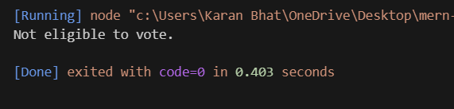

**Execution code:**

* Create a JavaScript file with any name
* Write the code
* And run the code in the terminal using F5 or right click and go to inspect and you can get the output in the console as well.